**Compile & Execute**

**Run your Hello World C++ program locally using the Terminal, Command Prompt, or Visual Studio Code.**

**The Process**

C++ is a compiled language. That means that to get a program to run, you must first translate it from the human-readable form to something a machine can “understand.” That translation is done by a program called a *compiler*.

What you read and write is called *source code* (usually it’s in an English-like language like C++), and what the computer executes is called *executable*, *object code*, or *machine code* (a machine language).

Typically C++ source code files are given the suffix:

* **.cpp** (ex: **hello.cpp**) or
* **.h** (ex: **std_lib_facilities.h**).

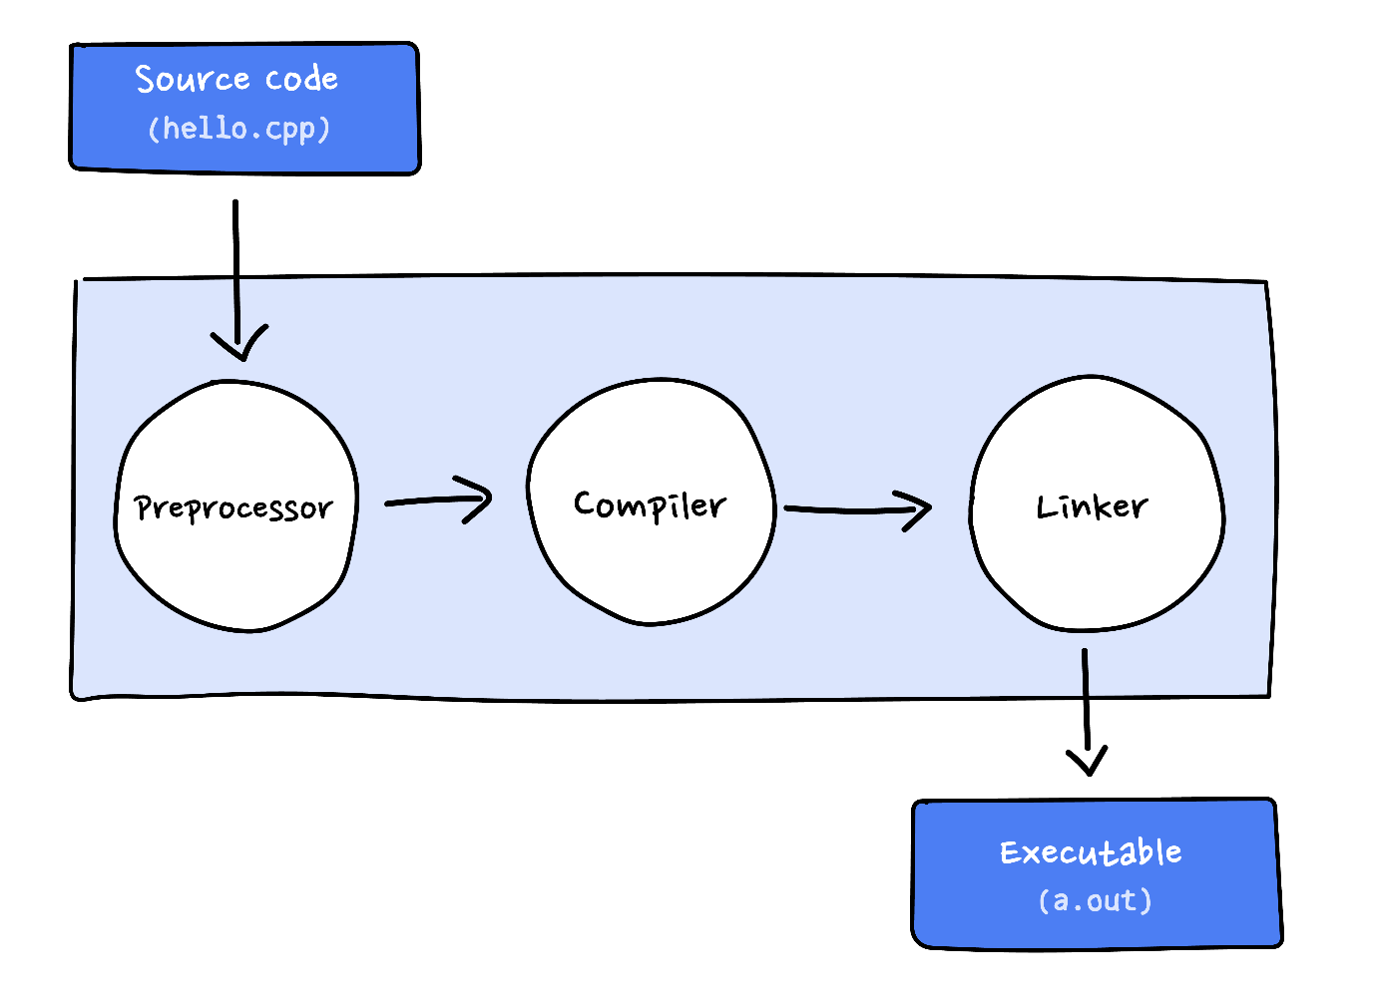

**Compile:**

g++ hello.cpp -o hello

A compiler translates the C++ program into machine language code which it stores on the disk as a file with the extension **.o** (e.g. **hello.o**). A linker then links the object code with standard library routines that the program may use and creates an executable image which is also saved on disk, usually as a file with the file name without any extension (e.g. **hello**).

**Execute:**

./hello

The executable is loaded from the disk to memory and the computer’s CPU (**C**entral **P**rocessing **U**nit) executes the program one instruction at a time.

**Running Hello World Locally:**

On the Mac, it’s called the Terminal. On Windows, it’s called the Command Prompt.

